**PRODUCTION LOG**

**Validation**

** This section should look at validation of the website, were you able to validate the website, were there any errors and if so, how did you go about fixing them. Please include a screenshot(s) of your validation report here **

Validation screenshots 19-04-17 -> validator used: <https://validator.w3.org/>

*(Selected input options - source/outline/image report)*

**index.html**

Resulted in one Warning for ‘Section lacks heading’.

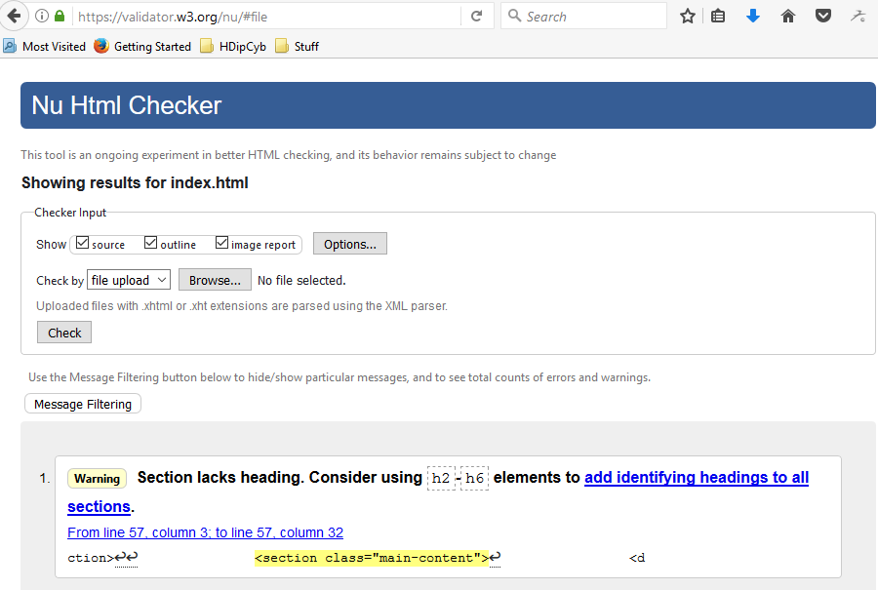

Image report indicating missing textual alternative (alt="")

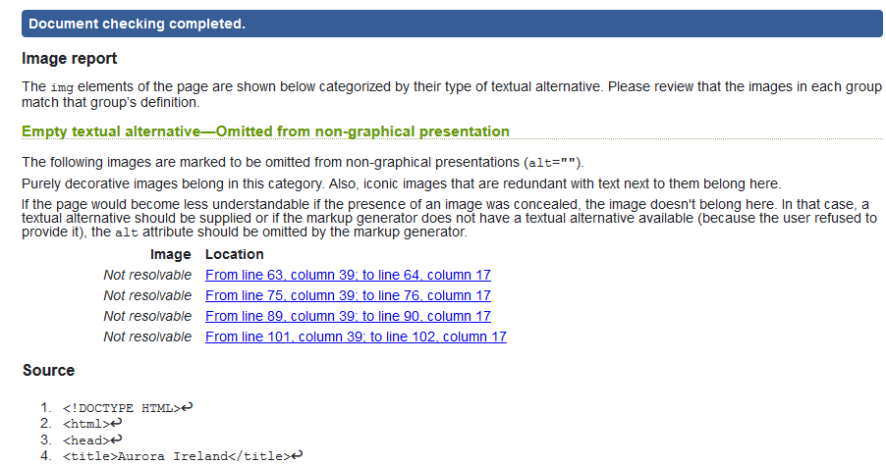

(some highlighted errors in source code shown below)

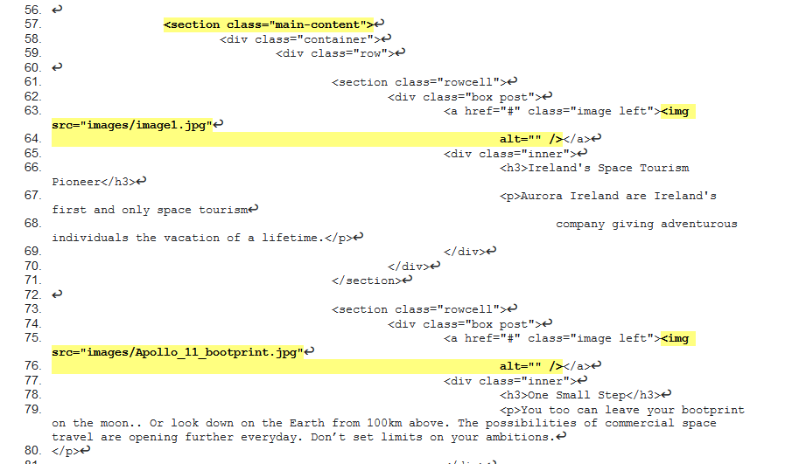

Validation screenshots 20-04-17 -> validator used: <https://validator.w3.org/>

*(Selected input options - source/outline/image report)*

**liftoff.html**  
Resulted in one Error for illegal character in path segment on source element, space is not allowed.   
Also, one Warning for ‘Section lacks heading’.

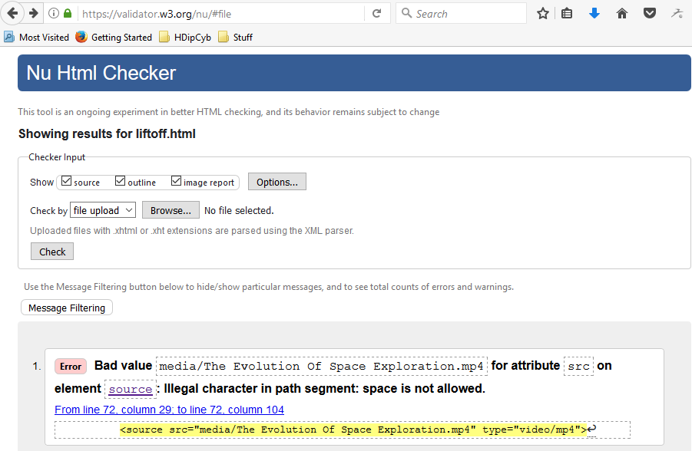

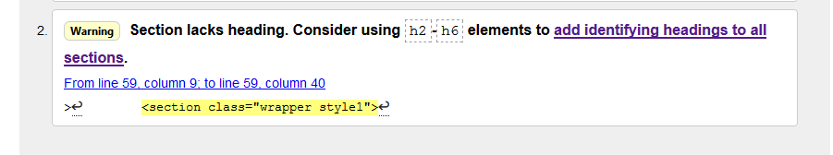

Image report suggests considering other textual alternatives  
  
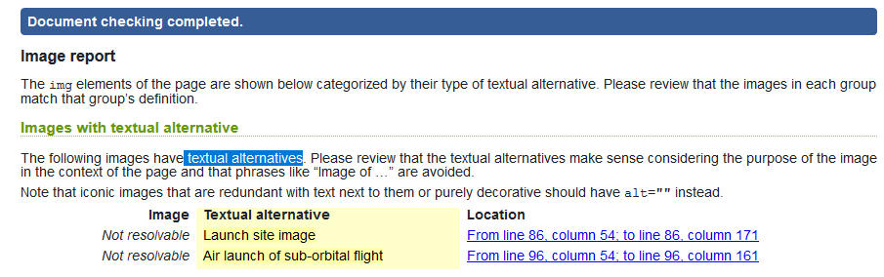

(some highlighted errors in source code shown below)

